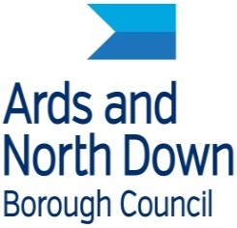
Ards and north down borough Council

AND Business at Signal Centre

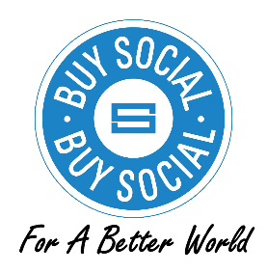
BUY SOCIAL FOR A BETTER WORLD: 7 – 12 October 2019
Expression of Interest
Buy Social for a Better World is a week-long campaign designed to champion Social Enterprises and recognise all the excellent work they do throughout the year. Ards and North Down Borough Council would like to recognise and raise awareness of all the Social Enterprises within the Borough and the positive impact they have on our local community. We are promoting local Social Enterprises as below to encourage people to #BuySocial.
BUY SOCIAL FOR A BETTER WORLD – Social Enterprise Spotlight Promotion

The Buy Social for a Better World campaign will run from Monday 7 October – Saturday 12 October 2019. This week provides an opportunity to celebrate, showcase and put a spotlight promotion on local Social Enterprises, recognising the excellent work they do and the benefits they bring to the local community.

Social Enterprise UK encourages as many Social Enterprises to run events or offer promotions during this week to encourage new customers to avail of their products/services and spread the word.

We would like to promote your Social Enterprise and/or your promotions, through Ards and North Down Borough Council’s AND Business ezine and Social Media, to encourage people to #BuySocial during the week. Each day throughout the week we will promote participating Social Enterprises through AND Social Media.

While the Council will assist with the promotion of your Social Enterprise and/or your promotions, you retain full legal responsibility and liability for all and any claims or actions which may arise from those promotions. You will further provide a full indemnity to the Council for any third party claims. Participation in the event is discretionary and the role of the Council is in the promotion of the campaign only.

If you would like to be featured in these spotlights or the special edition ezine to profile local social enterprises, including any of your planned events or promotions as part of the campaign, please fill in the form below.

Personal information
The Council will publish and process personal information you provide below on the basis of consent only. You should note that, as part of this promotion, personal information you provide in the form of a name and contact information may be widely published on social media and in an e-zine. As such, once the information is made publicly available, the Council has reduced control as to how third parties use that information.

You can withdraw your consent at any time by contacting Tory Killen on the address below. If you withdraw consent, the Council will take all reasonable steps to remove it from the public domain.

The Council will only hold your information until the conclusion of the promotional activity when it will be destroyed.

If you have queries as to how personal information may be used, please contact the Data Protection Officer at dataprotection@ardsandnorthdown.gov.uk.

I consent to have my information used and shared as described above (please tick):
YES |  |  | NO
Signature: Position: Date:

I would be interested in running/offering events/promotions for Buy Social for a Better World (please tick):
YES |  |  | NO
If YES please provide details of your Social Enterprise and proposed events/promotions. An Officer will be in contact for further details.

Type | Social Enterprise | CIC |  | Charity | Other  (Please provide detail below)
Full Postal Address
Contact Name & Position
Telephone
Opening Times
Email
Web Address
Product / Service /
Activity Description

Social Benefit

Signature: Position: Date:

Please complete this form and return it to tory.killen@ardsandnorthdown.gov.uk

