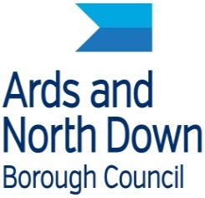
Ards and north down borough Council

Economic Development Department at Signal Centre

Mind Body and Business Active Business - Gym Challenge

Registration Form
Employee name

Business name
Business address
Home Address
Date of Birth

Contact number
Are you currently a member of a gym? | Yes/No
To participate in this program, the Council must confirm with SERCO and Ards Leisure that you do not already have a gym membership. Please confirm, by ticking this box, that you consent to the Council processing this information and to SERCO and Ards Leisure releasing this information.

You may withdraw your consent at any time, using the email address below, and leave this program. Data protection queries should be sent to dataprotection@ardsandnorthdown.gov.uk.
Signature

Preferred Leisure Facility

Please return completed registration forms to healthandwellbeing@ardsandnorthdown.gov.uk by 29 October 2018.
Completeing this form does not guarantee you will receive a gym pass as they are issued on a first come first served basis and are subject to checks with Ards Lesiure and SERCO that you do not currently hold a gym membership.

